Hospital Management :

Multi module

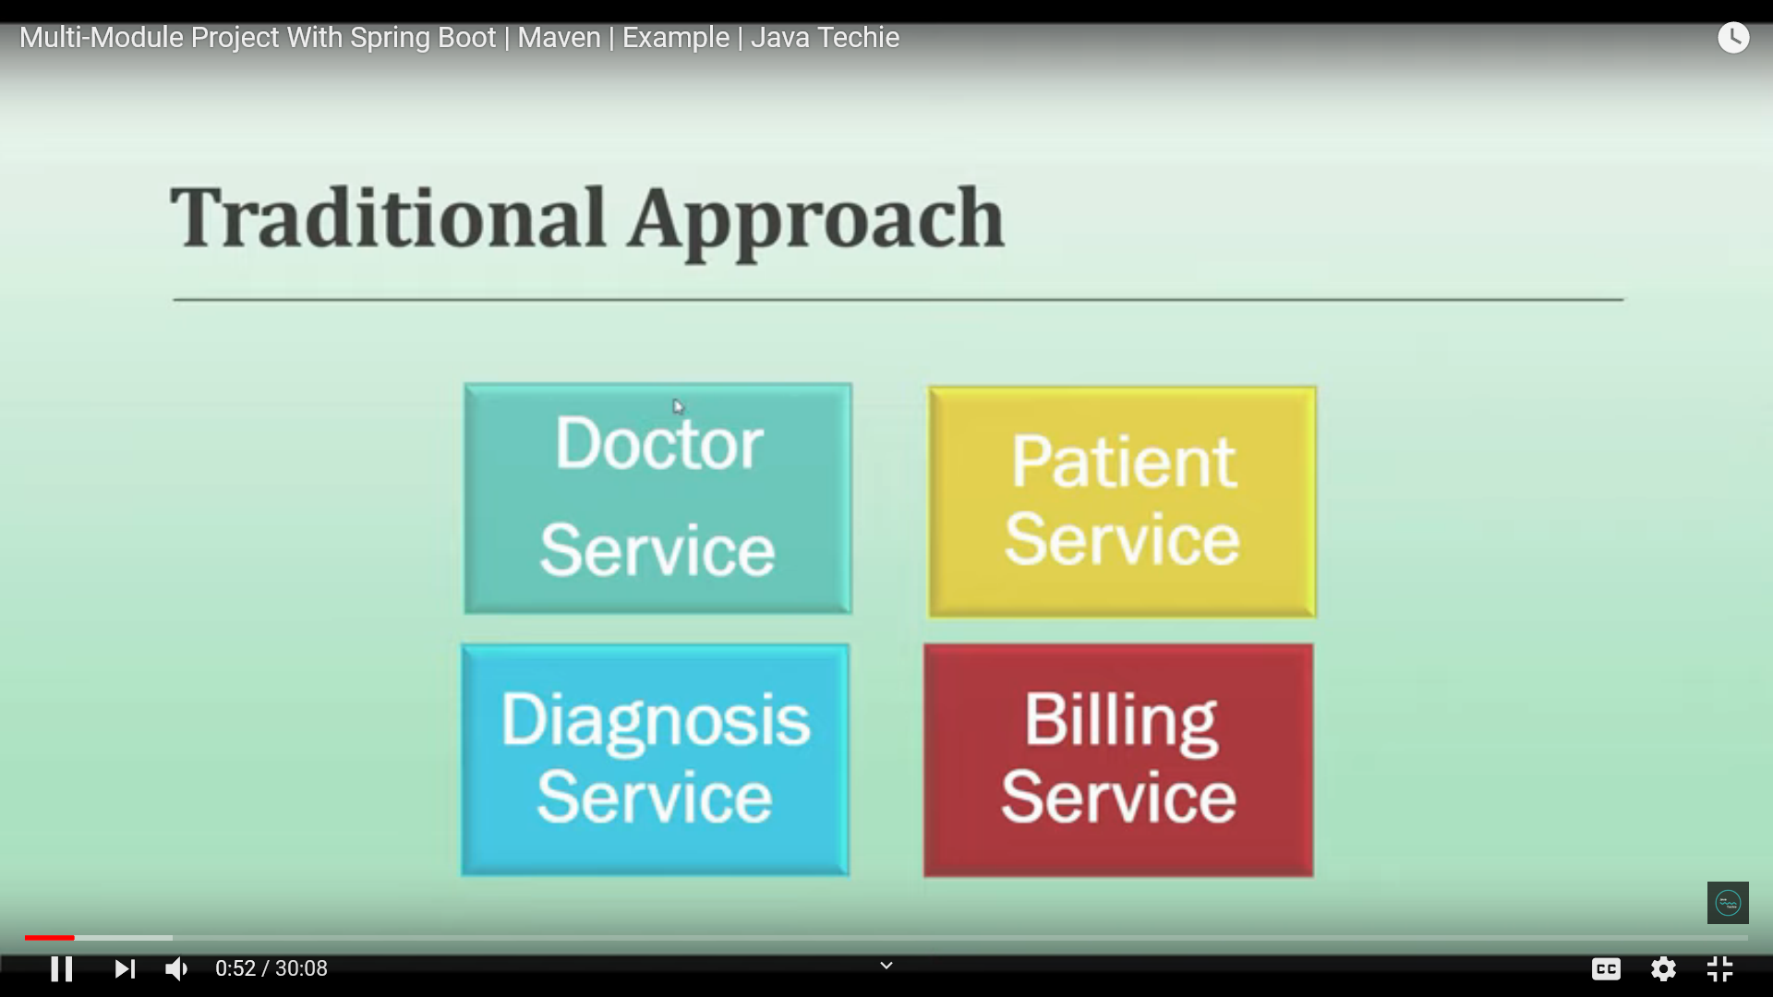

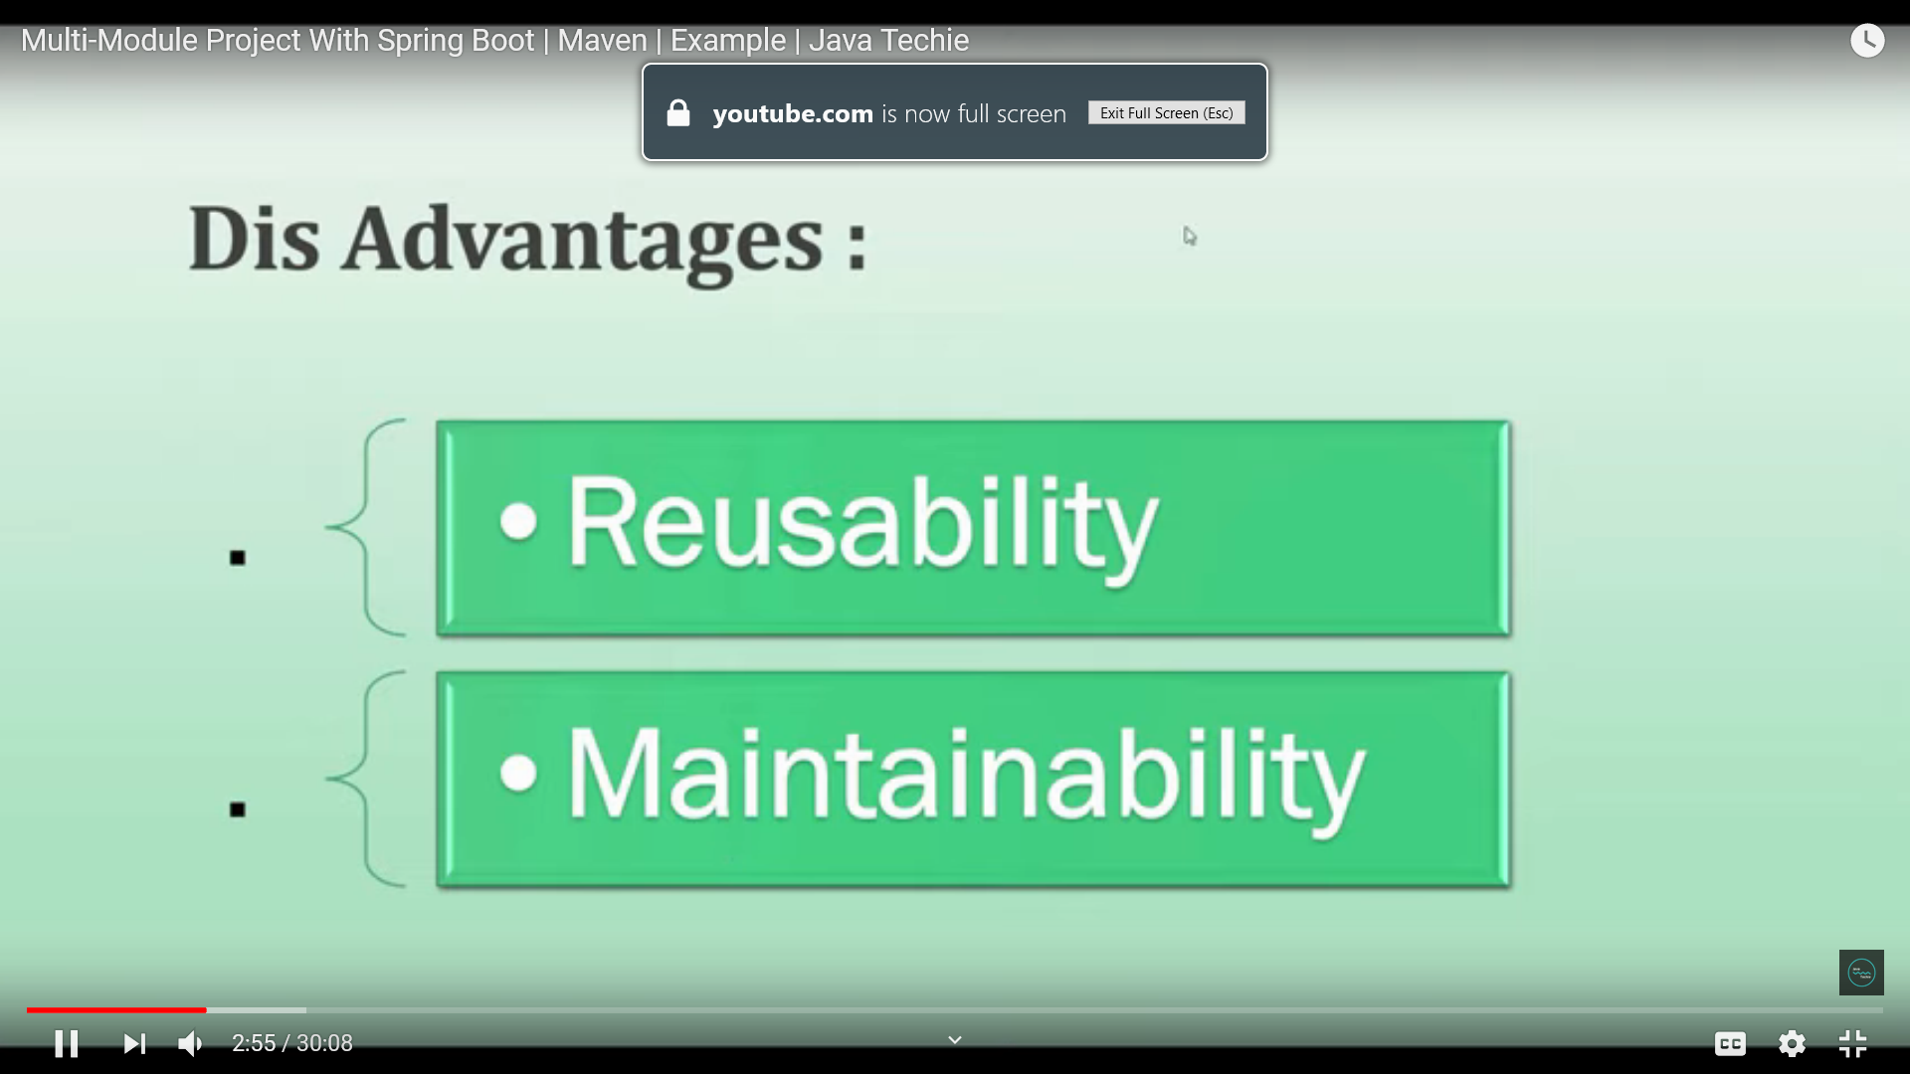

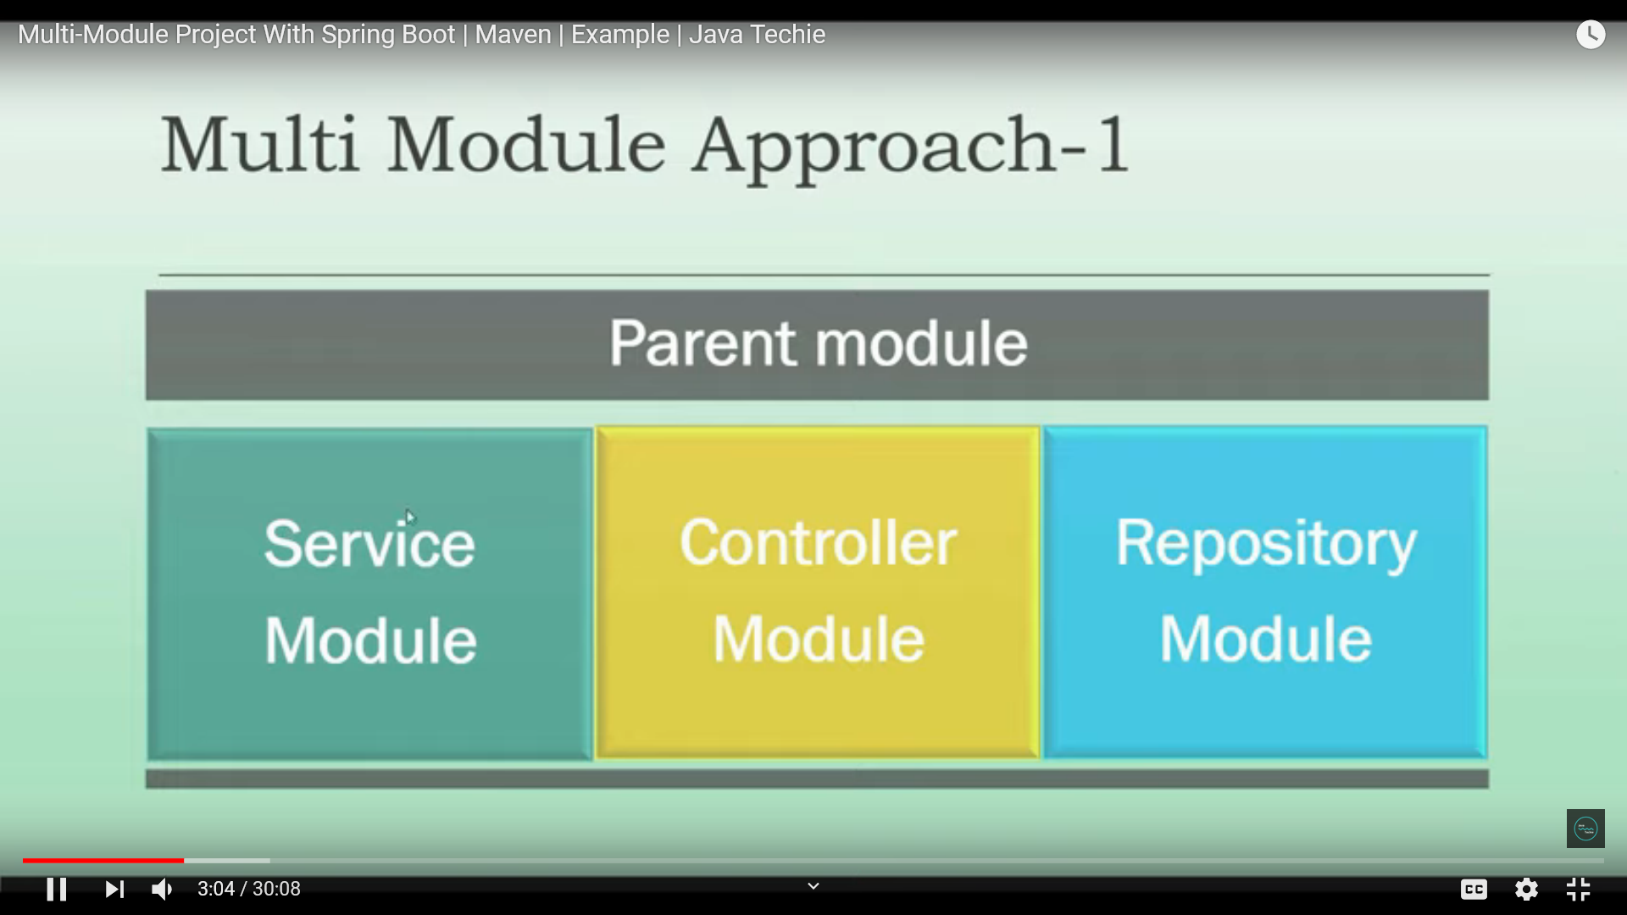

Our application will ahve 4 module

1 domain(bussiness , model)

2 repsoitory(Repsository and DB)

3 service

3 web (Entry point REST ,Main class)

//Add domain module as dependcy to Reposiroty to access those to import Doctor from that directory domain

// and in service module add reposirtor dependency to access in service